

**MULTI CYCLE PIPELINED RISCv BASED PROCESSOR**

**MULTI CYCLE PIPELINED RISC-V BASED PROCESSOR PROJECT PLAN**

|  |  |  |  |
| --- | --- | --- | --- |
| **Date** | **Document Version** | **Remarks** | **Drafted by** |
| 11- Sept- 2024 | Version 1.0 | Design Overview & Micro-architecture | By Team 7 |

**VERIFICATION DOCUMENT- ALU design**

CHAPTER 1 – DESIGN OVERVIEW 4

1.1 Multi Cycle Pipelined RISC-V Based Processor 4

1.2 Advantages 4

1.3 Disadvantages 4

1.4 Applications 4

1.5 Project Overview of : 4

1.6 Design Features: 5

1.7 Design Limitations: 5

CHAPTER 2 - Architecture 6

2.1 Micro-architecture: 6

2.2 Micro-architecture Components 6

2.2.1 Transaction 6

CHAPTER 3 - TESTBENCH IMPLEMENTATION 7

3.1 SV VERIFICATION CODE : 7

3.2 FUNCTIONAL COVERAGE 7

CHAPTER 4 – SIMULATION RESULTS AND ANALYSIS 11

4.1 TESTCASES FOR ALU design : 11

4.2 WAVEFORMS : 12

# **CHAPTER 1 – DESIGN OVERVIEW**

## **1.1 Multi Cycle Pipelined RISC-V Based Processor**

In the RISC-V processor, "RISC" refers to "Reduced Instruction Set Computer," indicating it operates with a streamlined set of instructions, while "V" signifies that it represents the fifth generation. RISC-V is an open-source hardware instruction set architecture (ISA) grounded in the RISC principles.

## **1.2 Advantages**

* The clock cycle can be much shorter.
* Can require less hardware.
* Could use a single memory for instructions and data.
* Can eliminate two adders.
* Allows different instructions to be executed in different number of cycles.

## **1.3 Disadvantages**

* More Complex Design: The pipeline needs special handling to manage different instruction stages, which makes the design harder to create and maintain.
* Stalling: When instructions depend on each other or need the same resources, the pipeline may have to pause, slowing things down.
* Waiting for Data: When an instruction needs data from a previous instruction (like loading data from memory), it may have to wait, which also slows things down.
* More Power Usage: With more moving parts in the pipeline, the processor consumes more power.
* Harder to Fix Errors: Because multiple things are happening at once in different stages, finding and fixing bugs can be tricky.

## **1.4 Applications**

* High-Performance Computing: Pipelined processors are used in supercomputers and data centers for parallel processing tasks, improving throughput and efficiency in intensive workloads.
* Embedded Systems: Many embedded devices use pipelined RISC-V processors for optimized performance in real-time applications such as automotive systems and IoT devices.
* Networking Devices: Routers, switches, and firewalls benefit from the increased throughput of pipelined processors, enabling fast data packet processing and routing.
* Mobile Devices: Smartphones and tablets use pipelined processors to balance power efficiency with performance, providing smooth multitasking and faster app execution.
* Gaming Consoles: Pipelined processors help improve the frame rate and graphical performance, enhancing user experience in gaming consoles by processing multiple instructions simultaneously.

## **1.5 Project Overview of :**

## **1.6 Design Features:**

* Logical Operations: ADD,SUB,AND,OR,XOR, NOP

## **1.7 Design Limitations:**

# **CHAPTER 2 - Architecture**

## **2.1 Micro-architecture:**

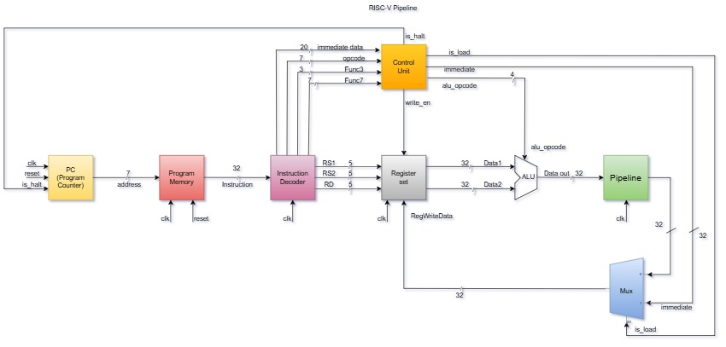

**Fig 2.1 Micro-architecture**

## **2.2 Micro-architecture Components**

## 

# **CHAPTER 3 - TESTBENCH IMPLEMENTATION**

## **3.1 SV VERIFICATION CODE :**